

**✮ LoRa base Smart Valve ✮**

**Project by (Product):** **Deepak Tukaram Hadkar**

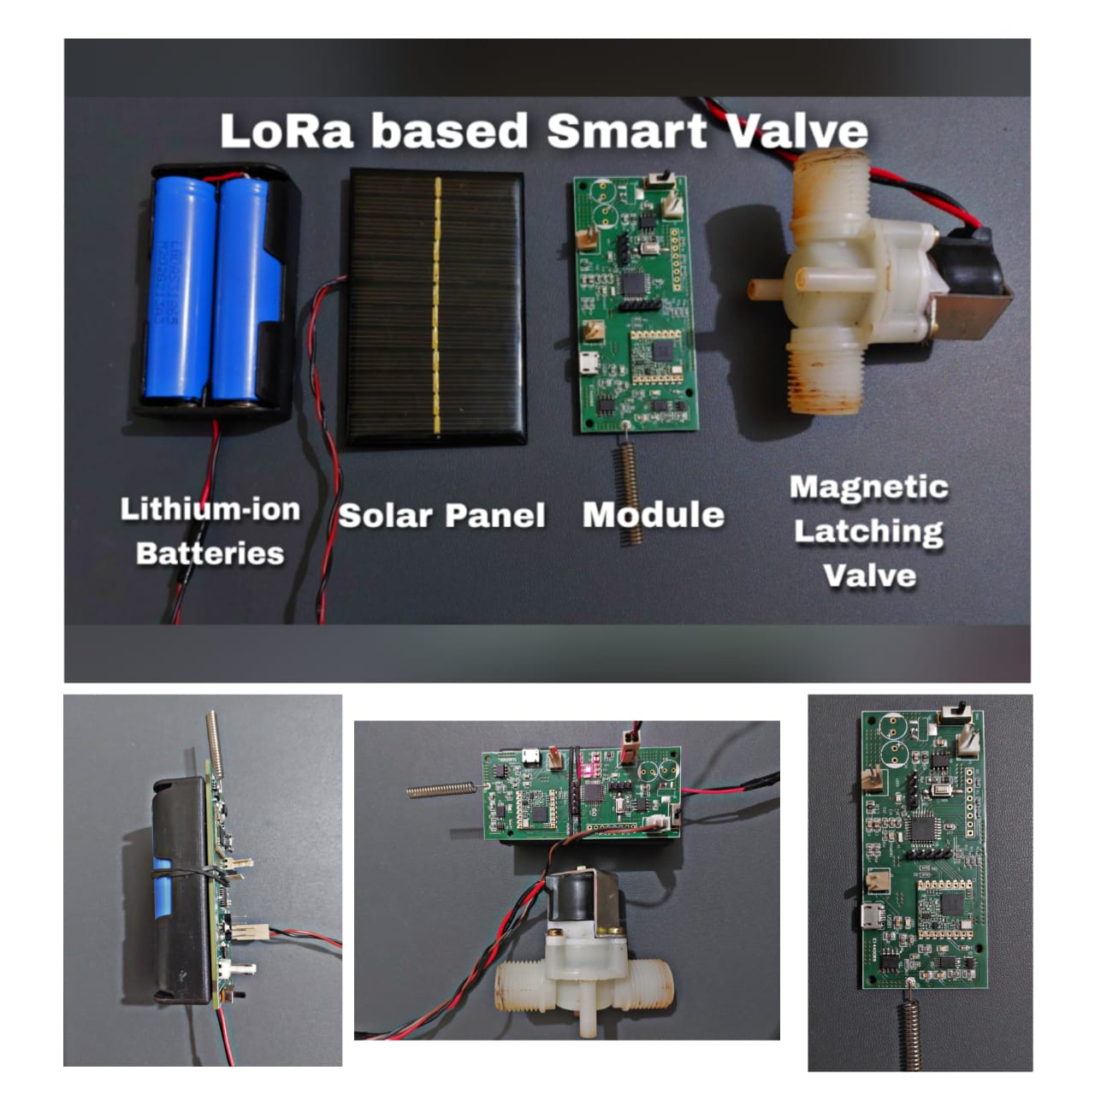

1. **Block Diagram of the entire system :**

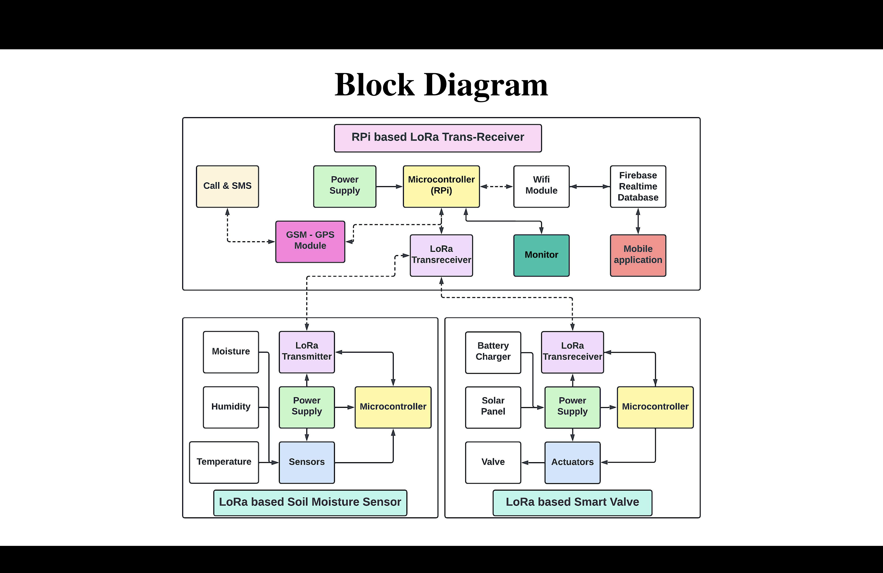

1. **Conceptual Model :**

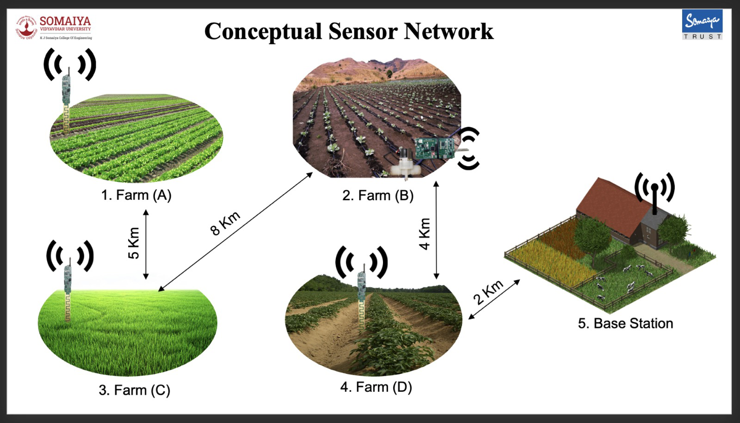

1. **Designing PCB for the Smart Valve:**

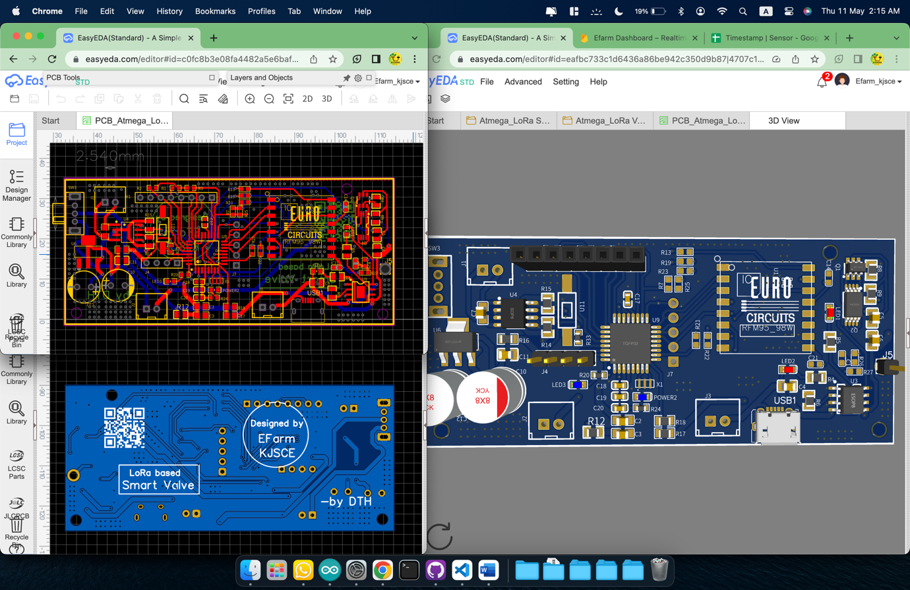



**QR Code for getting details**

1. **Ready PCB with all the components onboard:**

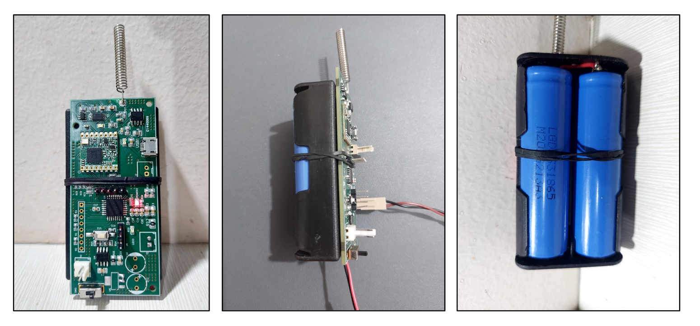

1. **Prize received:**

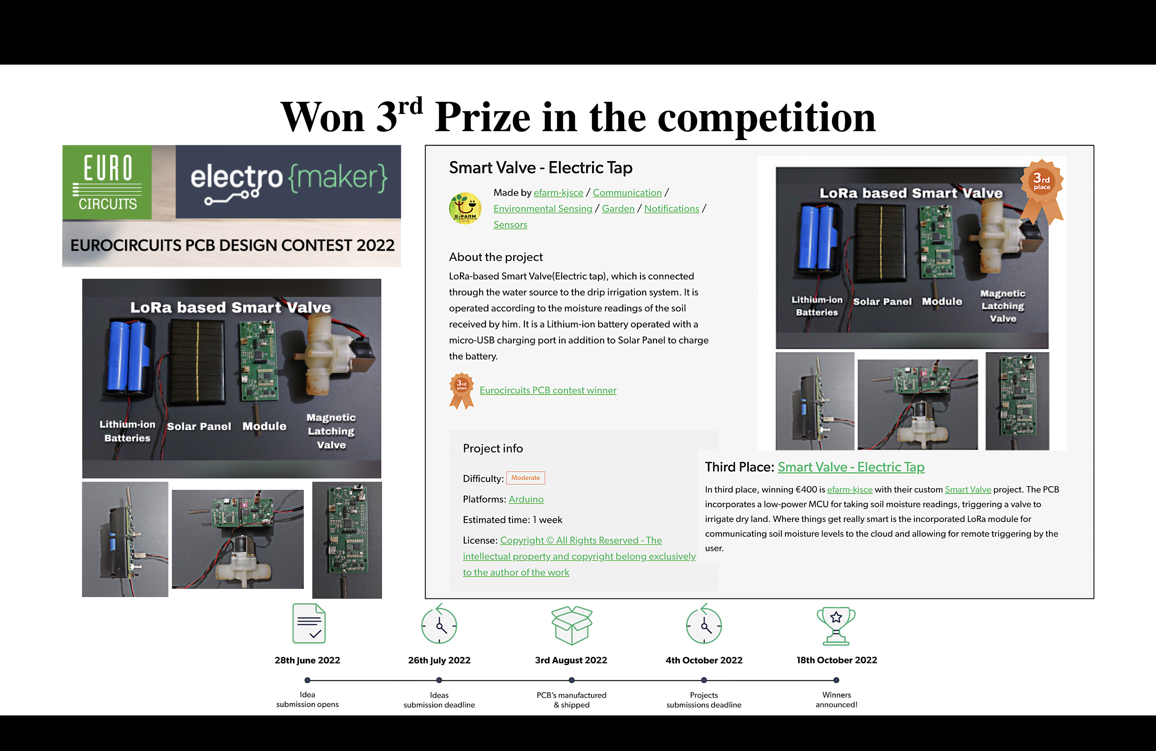

1. 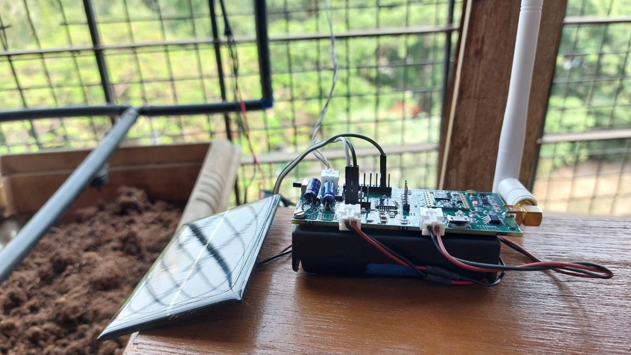**Implemented in Drip based Vertical Farming model (Prototype) :**



**Solar powered independent module**

1. **Implemented in Drip based Vertical Farming model (Prototype) :**

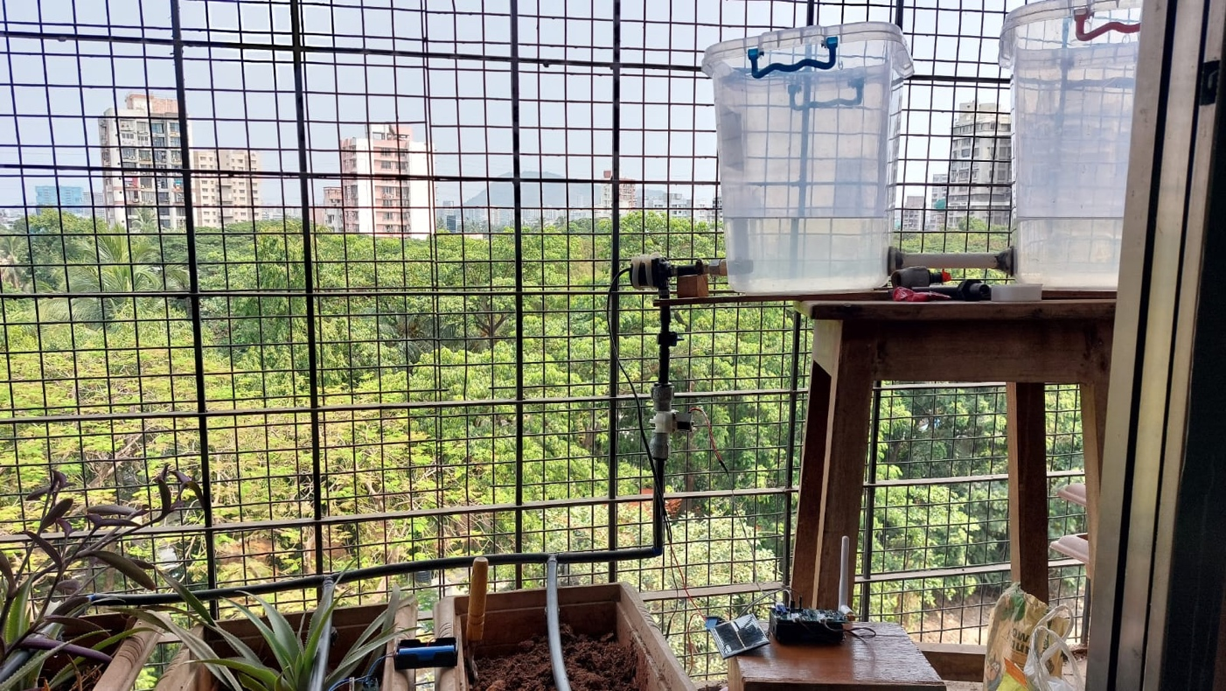

1. **Output ( Serial Monitor ) :**

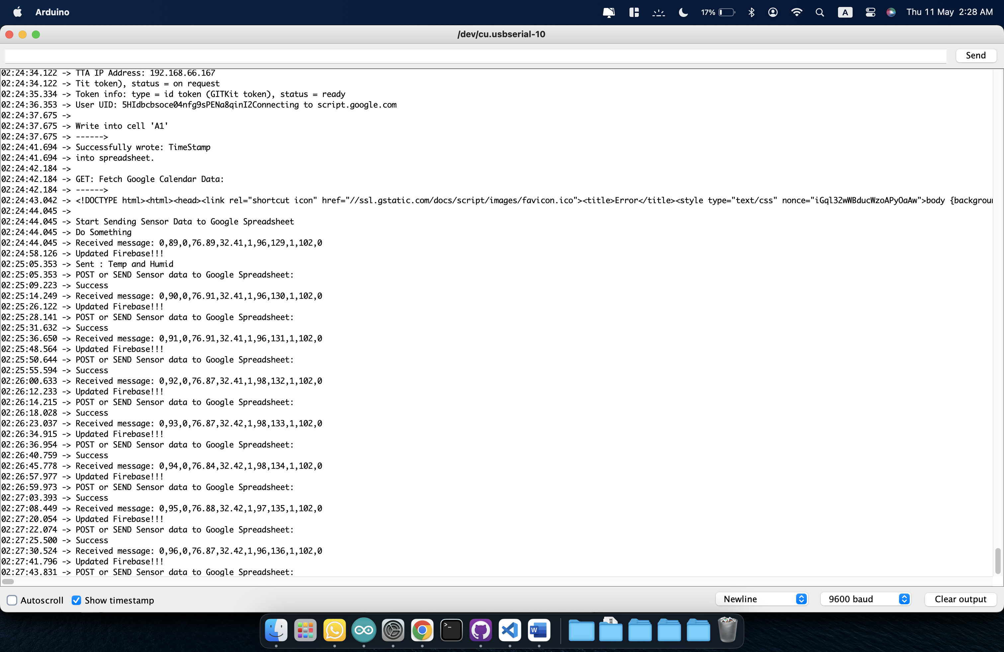

1. **Output ( Realtime Firebase Database ) :**

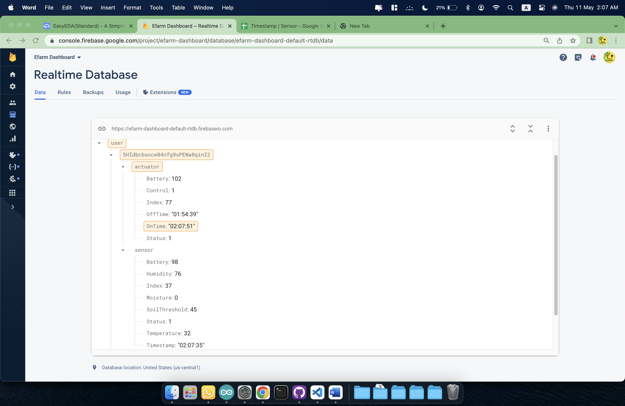



**Authenticated User!**

1. **Output ( Google Sheets ) – Realtime Data Logging:**

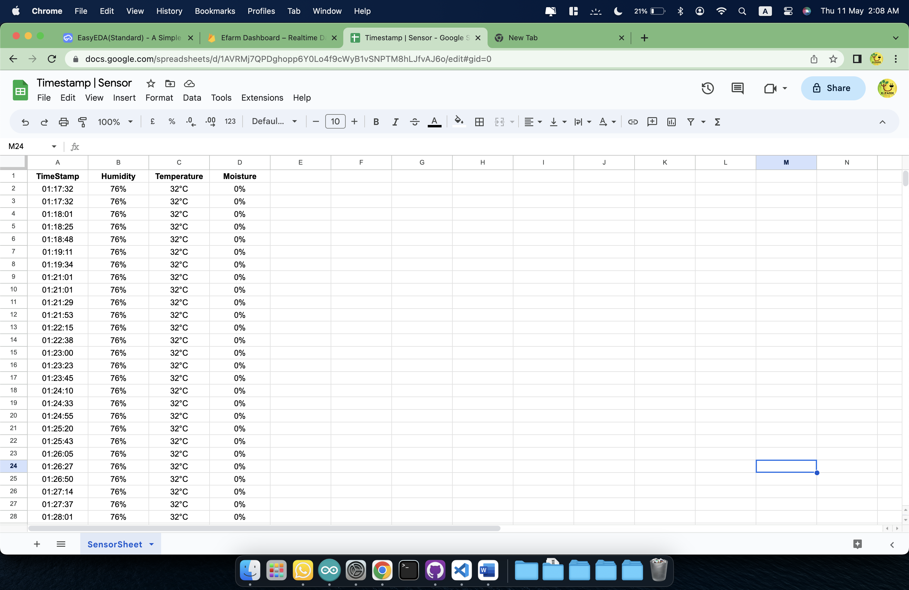

1. **Output ( Web Application ) :**

